OPTIONAL ACCESSORIES
Model | Item Description | Qty | Unit | Unit Price | PROMO AMOUNT
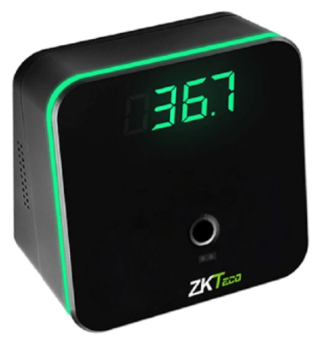  TMD95E | Model: TDM95E  Communication: USB 1.1  USB: Type-C  Temperature Detection: Distance 3 - 5cm  Temperature: Unit °C or °F  Temperature: Measurement Range 32.0°C - 42.9°C / 89.6°F - 109.22°F  Temperature Measurement Deviation: ±0.3°C / ±0.54°F  Digital Display: Tube 4  Operating Voltage: 5V  Operating Temperature: 15°C - 35°C / 59°F - 95°F  Operating Humidity: 10% - 85%  Dimensions: 88 * 88 * 54.63 (mm)  Weight of the Device: 0.17kg  Weight of the Device with Packaging: 0.29kg | 1 | pc | 9,500.00 | 9,500.00
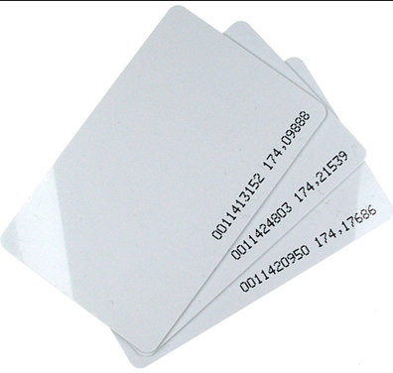 | Proximity Card 125khz(Thin) | 1 | pc | P80.00 | 80.00
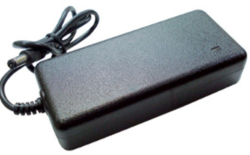 | 5v Mini Ups | 1 | pc | 2,500.00 | 2,500.00
 | 12v Mini Ups | 1 | pc | 3,500.00 | 3,500.00

